
Adam Fitzpatrick - C00273365

Pen-testing Multi-tool Project specification

Table of Contents
Introduction 3
Target Demographic 3
Technologies 3
Core Features 4
Wi-Fi Capabilities 4
Bluetooth Connectivity 4
Near Field Communications (NFC) 4
Non-Core Features 4
Infrared 4
Radio Frequency Identification (RFID) 4
Rubber Ducking 4
Metrics 5
Functionality 5
Usability 5
Reliability 5
Performance 6
Supportability 6
Walk-through of Usage 6
Context Diagram 7
Use Cases 8
Brief Use Cases 9
Capture Wi-Fi Data 9
CRUD Wi-Fi Data Log 9
Capture Bluetooth Data 9
CRUD Bluetooth Data Log 10
Pair With Device 10
Read NFC Chip 10
CRUD Clone NFC Signal 11
Emit Signal 11
Read RFID Frequency 11
CRUD Clone RFID Frequency 12
Relay RFID Frequency 12
Capture Infrared Signal 12
CRUD Clone Infrared Signal 13
Detailed Use Cases 14
Capture Wi-Fi Data 14
CRUD Wi-Fi Data Log 14
Capture Bluetooth Data 16
CRUD Bluetooth Data Log 16
Pair Bluetooth Device 18
Read NFC Chip 18
CRUD Clone NFC Signal 19
Emit NFC Signal 20
Read RFID Frequency 21
CRUD Clone RFID Signal 21
Emit RFID Signal 23
Read Infrared Signal 23
CRUD Clone Infrared Signal 24
Emit Infrared Signal 25
References 26

Introduction
The goal of this project is to create a multi-tool, like a Flipper Zero or Pwnagotchi, that has a variety of different utilities that can be used by red teams for pen-testing. The idea is to have the tool be as small as possible, preferably pocket sized, without compromising on its functionality or power.

Target Demographic
The target demographic for the multi-tool will be pen-testers, red teamers and anyone with an interest in hacking. Penetration testers, also known as pen-testers, simulate real world attacks on systems to “exploit vulnerabilities in a network, application, or system [1]”. Their primary goal is to attempt to utilize weaknesses to gain control or access of a system. A red teamer operates on a broader scale, not only identifying and attacking vulnerabilities in a system but also testing physical security too. Red teaming often involves elements of social engineering [2], utilizing tactics such as phishing, pretexting, or baiting to trick employees into revealing credentials or opening the door for further attacks.

Technologies
The hardware for this project will be a development board, preferably with built in Wi-Fi, Bluetooth and NFC / RFID modules, a display and a directional input multi-tool with buttons for control. The board may also have USB-C ports for external display and I/O multi-tool connectivity. Additional modules may also be added to the board if required. The multi-tool will also need a slot for a battery so that it can be used on the go. The hardware will preferably be encased with a plastic cover and possibly disguised to look like an ordinary, everyday multi-tool such as a power bank, portable hard drive or vape pen.
The operating system (OS) for the multi-tool will need to be built into the board and as such will need to be something light weight. The multi-tool will also need some way to manage the different capabilities. The multi-tool will also need a graphical user interface (GUI) for its display.
Listed below are some of the possible different technologies that could be utilized:
- Raspberry Pi Zero 2 WH / Raspberry Pi Pico / Banana Pi BPI M2 Zero/ ESP32
- Go (TinyGo) / Python (MiniPy)
- Kali Linux / Kali Nethunter / Pi OSFeatures

Core Features

Wi-Fi Capabilities
One of the key features of this multi-tool will be the ability to analyse Wi-Fi networks. Tools like Nmap or Wireshark would be used to scan IP addresses, look for open ports on a network and to capture packets. Once this information is captured a pen-tester or red-teamer could possibly use it for de-authentication, man-in-the-middle (MITM) attacks or possibly even Address Resolution Protocol (ARP) poisoning.

Bluetooth Connectivity
Another key feature of the multi-tool will be Bluetooth connectivity. A pen-tester will be able to connect Bluetooth multi-tools to the tool, use the multi-tool to scan for other multi-tools and collect data on them and possibly utilize the multi-tool for Bluetooth Low Energy MITM or jamming attacks.

Near Field Communications (NFC)
The multi-tool will have NFC capabilities such as reading, writing and emulating NFC tags allowing red teams to test the security of NFC-based systems such as access control badges, contactless payment systems, and identification cards.

Non-Core Features

Infrared
The infrared module will enable the multi-tool to capture and replay IR signals, commonly used in remote controls and IoT multi-tools. The multi-tool will function as a universal remote, capable of replaying captured IR signals to control and exploit systems, making it useful for targeting IoT multi-tools that rely on infrared for communication or control.

Radio Frequency Identification (RFID)
Like the NFC module, the multi-tool will also support the reading, cloning and emulation of RFID tags. The multi-tool will support low-frequency (125 kHz) and possibly high-frequency (13.56 MHz) RFID tagging.

Rubber Ducking
For this feature the multi-tool will be able to act as an I/O multi-tool and be able to automatically execute scripts on the multi-tool it is plugged into. This will be useful for various attacks, installing backdoors onto the multi-tools and for data extraction.

Metrics

Functionality
One of the key features of the multi-tool will be its capability for its size. The multi-tool must be able to effectively perform tasks without any compromise on its performance. The modules for each feature need to be able to integrate seamlessly with one another and provide an all-in-one utility for red teams. The multi-tool's ability to handle complex tasks across multiple attack vectors while remaining portable and easy to deploy will be its main measure of functionality. The device should take less than 2 minutes to become fully operational and should have at least 5 different vectors for attacking.

Usability
The multi-tool needs to be simple, concise and easy to navigate. Considering that the multi-tool will have a small form factor, any menus will need to be simplistic in design, while still conveying necessary information. The multi-tool will need to be well documented, ensuring that it is easy to use. Having a small form factor will also ensure that the multi-tool is comfortable to hold. Putting the multi-tool in a discreet plastic case will ensure that it is aesthetically pleasing. This means that the multi-tool will need to be smaller than a person’s hand (~20cm) [3].

Reliability
This multi-tool will need to be highly reliable, accurate and protected against failure. This is highly important as failures in the multi-tool will make it harder for pen-testers and red teamers to use and will increase the likelihood of being them being caught using it. Thus, the multi-tool must be able to operate without errors, minimize the likelihood of crashes and be able to recover quickly from any other failures or malfunctions. The multi-tool will need to be resilient and able to withstand different environmental conditions and mechanical stress. It will need to be able to perform well in both cold and hot temperatures and tool will need to be able to withstand being hit off floors, walls and other harder surfaces without breaking. The maximum operating temperature of a CPU is between 100°C-110°C [4], so ideally temperatures will need to be at least half of this.

Performance
The performance of the multi-tool will be evaluated based on how quickly it is able to carry out tasks. This includes fast packet capture for network sniffing, low-latency Bluetooth or NFC scanning, and rapid execution of USB Rubber Ducky scripts. It should take less than 100 milliseconds to scan and capture packets or any other signals. The multi-tool also needs to have a low level of battery consumption to ensure prolonged use.

Supportability
The supportability of this multi-tool means ensuring that it is easily maintainable and upgradable. The multi-tool will need to support modular hardware expansions without compromising on its form factor, which also may involve having external support such as user guides (for example a how-to on taking the multi-tool apart). The multi-tool also needs to remain compatible with existing technologies and cyber-security tools, which will mean ensuring that the firmware can be easily updated, ideally in less than an hour.

Walk-through of Usage
The following is an example of how a pen-tester / red-teamer would use the multi-tool in a real life scenario:
A penetration tester, Alex, enters an office building for a red team engagement with their pocket-sized multi-tool disguised as a power bank. Alex first activates the tool’s Wi-Fi sniffing feature to scan and capture the WPA2 handshake from the office’s wireless network by de-authenticating a connected user. The captured handshake is saved for offline password cracking later.
Next, Alex switches to Bluetooth scanning, detecting nearby devices like smartphones and a vulnerable office printer. Exploiting the printer’s weak pairing protocol, Alex gains unauthorized access, which could be used for further attacks on the network.
Alex approaches an employee with an RFID access badge, and they discreetly clone it using the multi-tool’s RFID scanning feature. This allows them to bypass a secure door later by emulating the badge. Inside, Alex finds an unattended workstation and plugs in the tool, executing a preloaded USB Rubber Ducky payload that installs a backdoor on the machine for remote access.
Before leaving, Alex tests an NFC-based payment terminal, scanning for potential weaknesses in its security protocols. After the on-site engagement, they review all captured data—Wi-Fi handshakes, RFID clones, and remote system access—completing a thorough and stealthy penetration test, all with a single, compact device.

Context Diagram
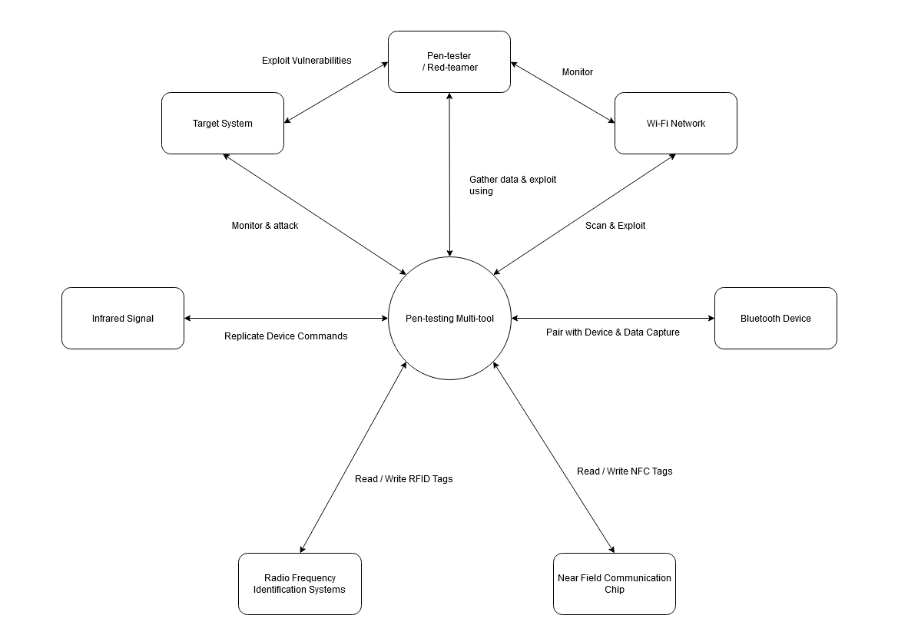

Use Cases
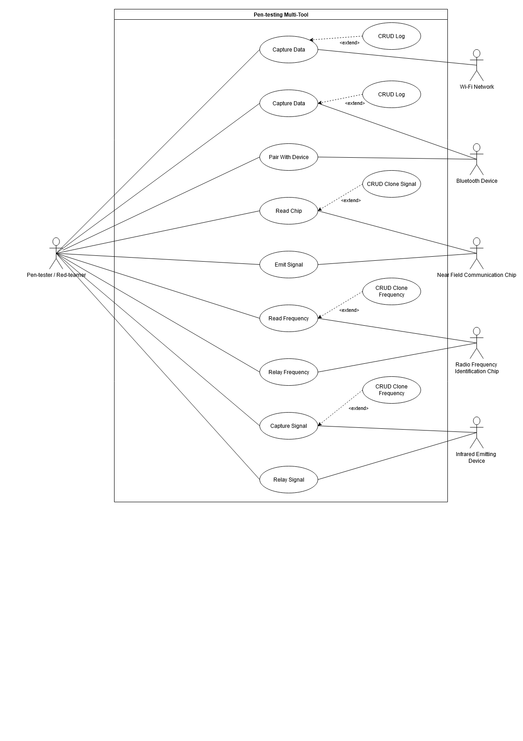

Brief Use Cases

Capture Wi-Fi Data
Actors:
Pen-tester, Wi-Fi Network
Description:
This use case begins when the pen-tester wishes to capture data from a Wi-Fi network. The pen-tester opens the multi-tool menu and selects the “Wi-Fi” option. From there they select the “Capture Data” option. After this they are prompted to select a network to capture the data from. The use case ends when the pen-tester decides to stop capturing data.

CRUD Wi-Fi Data Log
Actors:
Pen-tester
Description:
This use case begins when the pen-tester wishes to create, retrieve, update or delete a log of captured network data. The use case ends once the multi-tool has created, retrieved, updated or deleted a log.

Capture Bluetooth Data
Actors:
Pen-tester, Bluetooth Device
Description:
This use case begins when the pen-tester wishes to capture data from a Bluetooth Device. The pen-tester opens the multi-tool menu and selects the “Bluetooth” option. From there they select the “Capture Data” option. After this they are prompted to select a network to capture the data from. The use case ends when the pen-tester decides to stop capturing data.

CRUD Bluetooth Data Log
Actors:
Pen-tester
Description:
This use case begins when the pen-tester wishes to create, retrieve, update or delete a log of captured Bluetooth data. The use case ends once the multi-tool has created, retrieved, updated or deleted a log.

Pair With Device
Actors:
Pen-tester, Bluetooth Device
Description:
This use case begins when the pen-tester wishes to pair the multi-tool with a Bluetooth device. The pen-tester opens the multi-tool menu and selects the “Bluetooth” option. From there they select the “Pair” option. After this they are prompted to select a device to capture pair with. The use case ends when the pen-tester has successfully paired with a Bluetooth device.

Read NFC Chip
Actors:
Pen-tester, Near Field Communication Chip
Description:
This use case begins when the pen-tester wishes to read a signal from a Near Field Communication Chip. The pen-tester opens the multi-tool menu and selects the “NFC” option. From there they select the “Read” option. After this they are prompted to hold the device up to a NFC chip that is emitting a signal to scan it. The use case ends once the multi-tool successfully reads the signal.

CRUD Clone NFC Signal
Actors:
Pen-tester
Description:
This use case begins when the pen-tester wishes to create, retrieve, update or delete a cloned NFC signal. The use case ends once the multi-tool has created, retrieved, updated or deleted the signal.

Emit Signal
Actors:
Pen-tester, Near Field Communication Chip
Description:
This use case begins when the pen-tester wishes to emit a NFC signal from the multi-tool. Firstly, the pen-tester opens the multi-tool menu and selects “NFC” after this they select the “Emit” option. After this they are prompted to select a signal they wish to emit from the multi-tool. The use case ends once the selected signal is being emitted from the multi-tool.

Read RFID Frequency
Actors:
Pen-tester, Radio Frequency Identification Chip
Description:
This use case begins when the pen-tester wishes to read a signal from a Radio Frequency Identification Chip. The pen-tester opens the multi-tool menu and selects the “RFID” option. From there they select the “Read” option. After this they are prompted to hold the device up to a RFID chip that is emitting a signal to scan it. The use case ends once the multi-tool successfully reads the signal.

CRUD Clone RFID Frequency
Actors:
Pen-tester
Description:
This use case begins when the pen-tester wishes to create, retrieve, update or delete a cloned RFID signal. The use case ends once the multi-tool has created, retrieved, updated or deleted the signal.

Relay RFID Frequency
Actors:
Pen-tester, Radio Frequency Identification Chip
Description:
This use case begins when the pen-tester wishes to relay a RFID frequency from the multi-tool. The pen-tester opens the multi-tool menu and selects the “RFID” option. From there they select the “Relay” option. After this they are prompted to select the frequency that they wish to emit from the multi-tool. The use case ends once the multi-tool successfully reads the signal.

Capture Infrared Signal
Actors:
Pen-tester, Infrared Emitting Device
Description:
This use case begins when the pen-tester wishes to capture an infrared signal from a Radio Frequency Identification Chip. The pen-tester opens the multi-tool menu and selects the “RFID” option. From there they select the “Read” option. After this they are prompted to hold the device up to a RFID chip that is emitting a signal to scan it. The use case ends once the multi-tool successfully reads the signal.

CRUD Clone Infrared Signal
Actors:
Pen-tester
Description:
This use case begins when the pen-tester wishes to create, retrieve, update or delete a cloned infrared signal. The use case ends once the multi-tool has created, retrieved, updated or deleted the signal.

Detailed Use Cases

Capture Wi-Fi Data
Actors: | Pen-tester, Wi-Fi Network
Pre-conditions: | The multi-tool is charged.  The multi-tool has a Wi-Fi connection.  There are other Wi-Fi networks available nearby.
Main Success Scenario: | - The pen-tester opens the menu and selects the “Wi-Fi” option.  - The pen-tester then selects the “Capture Data” option in the sub-menu.  - The multi-tool then prompts the user to select a network to capture data from.
Post-conditions: | The multi-tool is successfully capturing data from the network.
Alternative(s): | 2a. The pen-tester cancels out of the sub-menu.  3a. The pen-tester cancels out of the search menu.  3b. There are no available networks for the multi-tool to connect to.

CRUD Wi-Fi Data Log
Actors: | Pen-tester
Pre-conditions: | The multi-tool is charged.  The multi-tool has obtained data from a network.
Main Success Scenario: | Create Data Log  - The pen-tester is prompted by the multi-tool to create a log after data capture.  - The pen-tester selects the “Yes” option.  Retrieve Data Log  - The multi-tool retrieves the names of all logs stored on the device and lists them by creation date.  - The pen-tester selects which log they wish to view from the menu.  - The multi-tool retrieves the log from storage and displays the details to the pen-tester.  Delete Data Log  - The multi-tool retrieves the names of all logs stored on the device and lists them by creation date.  - The pen-tester selects which log they wish to delete from the menu.  - The multi-tool prompts the pen-tester to confirm deletion.  - The pen-tester selects the “Yes” option.  - The multi-tool deletes the log from storage.  - A confirmation screen is displayed to the pen-tester.
Post-conditions: | Create Data Log  A log of Wi-Fi network data is created.  Retrieve Data Log  A specified log of Wi-Fi network data is retrieved by the multi-tool.  Delete Data Log  A specified log of Wi-Fi network data is deleted.
Alternative(s): | Create Data Log  2a. The pen-tester selects the “No” option.  Retrieve Data Log  1a. There are no data logs to be retrieved.  2a. The pen-tester cancels out of the menu.  Delete Data Log  1a. There are no data logs to be deleted.  2a. The pen-tester cancels out of the menu.  4a. The pen-tester selects the “No” option.

Capture Bluetooth Data
Actors: | Pen-tester, Bluetooth Device
Pre-conditions: | The multi-tool is charged.  There is at least 1 other Bluetooth enabled device nearby.
Main Success Scenario: | - The pen-tester opens the menu on the multi-tool and selects the “Bluetooth” option.  - The pen-tester selects the “Capture Data” option from the sub-menu.
Post-conditions: | The multi-tool is successfully capturing data from nearby Bluetooth devices.
Alternative(s): | 2a. The pen-tester cancels out of the menu.

CRUD Bluetooth Data Log
Actors: | Pen-tester
Pre-conditions: | The multi-tool is charged.  The multi-tool has obtained data from a Bluetooth device.
Main Success Scenario: | Create Data Log  - The pen-tester is prompted by the multi-tool to create a log after data capture.  - The pen-tester selects the “Yes” option.  Retrieve Data Log  - The multi-tool retrieves the names of all logs stored on the device and lists them by creation date.  - The pen-tester selects which log they wish to view from the menu.  - The multi-tool retrieves the log from storage and displays the details to the pen-tester.  Delete Data Log  - The multi-tool retrieves the names of all logs stored on the device and lists them by creation date.  - The pen-tester selects which log they wish to delete from the menu.  - The multi-tool prompts the pen-tester to confirm deletion.  - The pen-tester selects the “Yes” option.  - The multi-tool deletes the log from storage.  - A confirmation screen is displayed to the pen-tester.
Post-conditions: | Create Data Log  A log of captured Bluetooth data is created.  Retrieve Data Log  A specified log of Bluetooth data is retrieved by the multi-tool.  Delete Data Log  A specified log of Bluetooth data is deleted.
Alternative(s): | Create Data Log  2a. The pen-tester selects the “No” option.  Retrieve Data Log  1a. There are no data logs to be retrieved.  2a. The pen-tester cancels out of the menu.  Delete Data Log  1a. There are no data logs to be deleted.  2a. The pen-tester cancels out of the menu.  4a. The pen-tester selects the “No” option.

Pair Bluetooth Device
Actors: | Pen-tester, Bluetooth Device
Pre-conditions: | The multi-tool is charged.  There is at least 1 other Bluetooth enabled device nearby.
Main Success Scenario: | - The pen-tester opens the menu on the device and selects the “Bluetooth” option.  - The pen-tester selects the “Pair” option from the sub-menu.  - The multi-tool shows the pen-tester a list of available devices to pair with.  - The pen-tester selects a device to pair with.
Post-conditions: | The multi-tool successfully pairs with a Bluetooth device.
Alternative(s): | 2a. The pen-tester cancels out of the menu.

Read NFC Chip
Actors: | Pen-tester, Near Field Communication Chip
Pre-conditions: | The multi-tool is charged.  There is a NFC chip nearby.
Main Success Scenario: | - The pen-tester opens the menu on the multi-tool and selects the “NFC” option.  - The pen-tester selects the “Read” option from the sub-menu.  - The multi-tool prompts the pen-tester to hold it up to the NFC chip.
Post-conditions: | The multi-tool is successfully reads the NFC chip.
Alternative(s): | 2a. The pen-tester cancels out of the menu.  3a. The pen-tester cancels out of the menu.  3b. There is no nearby NFC chip.

CRUD Clone NFC Signal
Actors: | Pen-tester
Pre-conditions: | The multi-tool is charged.  The multi-tool has successfully scanned a NFC chip.
Main Success Scenario: | Create Clone  - The pen-tester is prompted by the multi-tool to create clone of the NFC signal.  - The pen-tester selects the “Yes” option.  Retrieve Clone  - The multi-tool retrieves the names of all cloned signals stored on the device and lists them by creation date.  - The pen-tester selects which clone they wish to view from the menu.  - The multi-tool retrieves the cloned signal from storage and displays the details to the pen-tester.  Delete Clone  - The multi-tool retrieves the names of all cloned signals stored on the device and lists them by creation date.  - The pen-tester selects which signal they wish to delete from the menu.  - The multi-tool prompts the pen-tester to confirm deletion.  - The pen-tester selects the “Yes” option.  - The multi-tool deletes the signal from storage.  - A confirmation screen is displayed to the pen-tester.
Post-conditions: | Create Clone  A clone of a NFC signal is created.  Retrieve Clone  A specified clone of a NFC signal is retrieved by the multi-tool.  Delete Clone  A specified clone of a NFC signal is deleted.
Alternative(s): | Create Clone  2a. The pen-tester selects the “No” option.  Retrieve Clone  1a. There are no signals to be retrieved.  2a. The pen-tester cancels out of the menu.  Delete Clone  1a. There are no signals to be deleted.  2a. The pen-tester cancels out of the menu.  4a. The pen-tester selects the “No” option.

Emit NFC Signal
Actors: | Pen-tester, Near Field Communication Chip
Pre-conditions: | The multi-tool is charged.  There is a NFC reader nearby.
Main Success Scenario: | - The pen-tester opens the menu on the multi-tool and selects the “NFC” option.  - The pen-tester selects the “Emit” option from the sub-menu.  - The multi-tool prompts the pen-tester to hold it up to the NFC reader.
Post-conditions: | The multi-tool is successfully emits the NFC signal.
Alternative(s): | 2a. The pen-tester cancels out of the menu.  3a. The pen-tester cancels out of the menu.  3b. There is no nearby NFC reader.

Read RFID Frequency
Actors: | Pen-tester, Radio Frequency Identification Chip
Pre-conditions: | The multi-tool is charged.  There is a RFID chip nearby.
Main Success Scenario: | - The pen-tester opens the menu on the multi-tool and selects the “RFID” option.  - The pen-tester selects the “Read RFID” option from the sub-menu.  - The multi-tool prompts the pen-tester to hold it up to the RFID chip.
Post-conditions: | The multi-tool is successfully reads the RFID chip.
Alternative(s): | 2a. The pen-tester cancels out of the menu.  3a. The pen-tester cancels out of the menu.  3b. There is no nearby RFID chip.

CRUD Clone RFID Signal
Actors: | Pen-tester
Pre-conditions: | The multi-tool is charged.  The multi-tool has successfully scanned a RFID chip.
Main Success Scenario: | Create Clone  - The pen-tester is prompted by the multi-tool to create clone of the RFID signal.  - The pen-tester selects the “Yes” option.  Retrieve Clone  - The multi-tool retrieves the names of all cloned signals stored on the device and lists them by creation date.  - The pen-tester selects which clone they wish to view from the menu.  - The multi-tool retrieves the cloned signal from storage and displays the details to the pen-tester.  Delete Clone  - The multi-tool retrieves the names of all cloned signals stored on the device and lists them by creation date.  - The pen-tester selects which signal they wish to delete from the menu.  - The multi-tool prompts the pen-tester to confirm deletion.  - The pen-tester selects the “Yes” option.  - The multi-tool deletes the signal from storage.  - A confirmation screen is displayed to the pen-tester.
Post-conditions: | Create Clone  A clone of a RFID signal is created.  Retrieve Clone  A specified clone of a RFID signal is retrieved by the multi-tool.  Delete Clone  A specified clone of a RFID signal is deleted.
Alternative(s): | Create Clone  2a. The pen-tester selects the “No” option.  Retrieve Clone  1a. There are no signals to be retrieved.  2a. The pen-tester cancels out of the menu.  Delete Clone  1a. There are no signals to be deleted.  2a. The pen-tester cancels out of the menu.  4a. The pen-tester selects the “No” option.

Emit RFID Signal
Actors: | Pen-tester, Radio Frequency Identification Chip
Pre-conditions: | The multi-tool is charged.  There is a RFID reader nearby.
Main Success Scenario: | - The pen-tester opens the menu on the multi-tool and selects the “RFID” option.  - The pen-tester selects the “Emit” option from the sub-menu.  - The multi-tool prompts the pen-tester to hold it up to the RFID reader.
Post-conditions: | The multi-tool is successfully emits the RFID signal.
Alternative(s): | 2a. The pen-tester cancels out of the menu.  3a. The pen-tester cancels out of the menu.  3b. There is no nearby RFID reader.

Read Infrared Signal
Actors: | Pen-tester, Radio Frequency Identification Chip
Pre-conditions: | The multi-tool is charged.  There is an Infrared chip nearby.
Main Success Scenario: | - The pen-tester opens the menu on the multi-tool and selects the “Infrared” option.  - The pen-tester selects the “Read” option from the sub-menu.  - The multi-tool prompts the pen-tester to hold it up to the Infrared chip.
Post-conditions: | The multi-tool is successfully reads the Infrared signal.
Alternative(s): | 2a. The pen-tester cancels out of the menu.  3a. The pen-tester cancels out of the menu.  3b. There is no nearby Infrared signal.

CRUD Clone Infrared Signal
Actors: | Pen-tester
Pre-conditions: | The multi-tool is charged.  The multi-tool has successfully scanned an Infrared signal.
Main Success Scenario: | Create Clone  - The pen-tester is prompted by the multi-tool to create clone of the infrared signal.  - The pen-tester selects the “Yes” option.  Retrieve Clone  - The multi-tool retrieves the names of all cloned signals stored on the device and lists them by creation date.  - The pen-tester selects which clone they wish to view from the menu.  - The multi-tool retrieves the cloned signal from storage and displays the details to the pen-tester.  Delete Clone  - The multi-tool retrieves the names of all cloned signals stored on the device and lists them by creation date.  - The pen-tester selects which signal they wish to delete from the menu.  - The multi-tool prompts the pen-tester to confirm deletion.  - The pen-tester selects the “Yes” option.  - The multi-tool deletes the signal from storage.  - A confirmation screen is displayed to the pen-tester.
Post-conditions: | Create Clone  A clone of an infrared signal is created.  Retrieve Clone  A specified clone of an infrared signal is retrieved by the multi-tool.  Delete Clone  A specified clone of an infrared signal is deleted.
Alternative(s): | Create Clone  2a. The pen-tester selects the “No” option.  Retrieve Clone  1a. There are no signals to be retrieved.  2a. The pen-tester cancels out of the menu.  Delete Clone  1a. There are no signals to be deleted.  2a. The pen-tester cancels out of the menu.  4a. The pen-tester selects the “No” option.

Emit Infrared Signal
Actors: | Pen-tester, Radio Frequency Identification Chip
Pre-conditions: | The multi-tool is charged.  There is an Infrared reader nearby.
Main Success Scenario: | - The pen-tester opens the menu on the multi-tool and selects the “Infrared” option.  - The pen-tester selects the “Emit” option from the sub-menu.  - The multi-tool prompts the pen-tester to hold it up to the infrared reader.
Post-conditions: | The multi-tool is successfully emits the infrared signal.
Alternative(s): | 2a. The pen-tester cancels out of the menu.  3a. The pen-tester cancels out of the menu.  3b. There is no nearby infrared reader.

References
[1] Threatintelligence.com. (2022). Penetration Testing vs Red Teaming: What’s the Difference? [online] Available at: https://www.threatintelligence.com/blog/penetration-testing-vs-red-teaming [Accessed 13 Oct. 2024].
[2] CareerExplorer (2023). What does a red teamer do? [online] Careerexplorer.com. Available at: https://www.careerexplorer.com/careers/red-teamer/ [Accessed 14 Oct. 2024].
[3] www.medicalnewstoday.com. (2020). Average hand size: Adults, children, and relation to height. [online] Available at: https://www.medicalnewstoday.com/articles/average-hand-size#children.
‌[4] Intel. (n.d.). What Is the Maximum Operating Temperature of My Intel® Processor? [online] Available at: https://www.intel.com/content/www/us/en/support/articles/000094759/processors.html.

